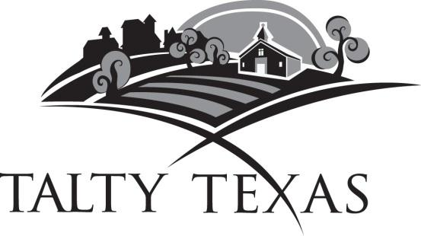

AGENDA FOR CITY COUNCIL MEETING
PUBLIC HEARING AND
BUDGET WORKSHOP
SEPTEMBER 3, 2020

The Talty City Council will hold a Public Hearing on the Fiscal 2021 Budget and a proposal to increase total tax revenues from properties on the tax roll to remain at the proposed $0.246654 tax rate for 2020. The public hearing will begin at 6:30 pm on Thursday, September 3, 2020, at the Trinity Family Church, located at the intersection of FM 1641 and I-20, to consider the following:

I. Call to Order: Mayor Garrison will announce a quorum and
Open the Public Hearing on the proposed 2021 Budget.

II. The Public Hearing will close on the proposed 2021 Budget.

III. Invocation and Pledge of Allegiance: Please rise for the invocation and pledge.

IV. Citizen Participation: Citizens wishing to address the City Council may do so at this time. Each citizen will have three minutes to address the Council.

V. Discussion Budget Workshop:
Discuss the budget for the next fiscal year beginning October 1, 2020.

VIII. Adjourn Meeting

_______________ _______
Sherry Bagby, City Secretary of Talty

As authorized by Section 551.071, 551.072, 551.073, 551.074, 551.076, 551.087 of the Texas Government Code, this meeting may be convened into closed executive Session. This building is wheelchair accessible. Any request for sign interpretive services must be made 48 hours ahead of the meeting. To make arrangements, call (972) 552-9592 or (TDD) 1-800-735-2989. I hereby certify that this Agenda has been posted at Talty City Hall, 9550 Helms Trail, Suite 500, Forney, Texas 75126 by 7:00 p.m. on Sunday, August 29, 2020.

